**Descriptive scenarios and storyboards**

**Scenario One:**

Teri and her daughter, Morata, want to get flowers for Morata’s upcoming wedding. They visit the “weddings” branch of the website and view several examples of recent wedding flowers. They decide that they want to go with KFC, so they go to the “request appointment” page.

1.What does this scenario tell you about displaying EXAMPLE IMAGES to the WEBSITE?

A. The example images displayed in the website are the kinds of flowers available in KFC. They are displayed to attract the customers. The customers can also know what are the types of flowers that are on sale. It includes different types of flowers for various occasions like wedding, funeral, birthday and valentine's day.

2. What does this scenario tell you about the nature of EXPLORING the WEBSITE?

A. The website includes sections for different fields. For example, if a customer wants to view the several examples of the wedding flowers they have to visit the "wedding" branch of the website. If a customer wanted to purchase from the website, they have to visit the "Request appointment page".

3.What does this scenario tell you about the nature of CUSTOMER INFORMATION on the WEBSITE?

A. When the customer clicks on the "Request Appointment", the customer has to fill their information like name, phone number and email id. Customers need to give their information so that the KFC representatives can get back to them with a scheduled appointment.

4. What does she need to do to set up an appointment? Is there an ORDERING of tasks?

A. She needs to visit the "Request Appointment" page of the website in order to set up an appointment.

5. Does this website have available appointment times?

The website does not have available appointment times. The customers need to fill out their information and click submit.

6. What does this scenario tell you about the attributes and the entities in the WEBSITE?

The website consists of various entities like images, flowers. The website also contains different pages like home page, wedding page and other services. The home page is an overview of the website. The Gallery shows the images of all the flowers. You can also schedule an appointment with the KFC.

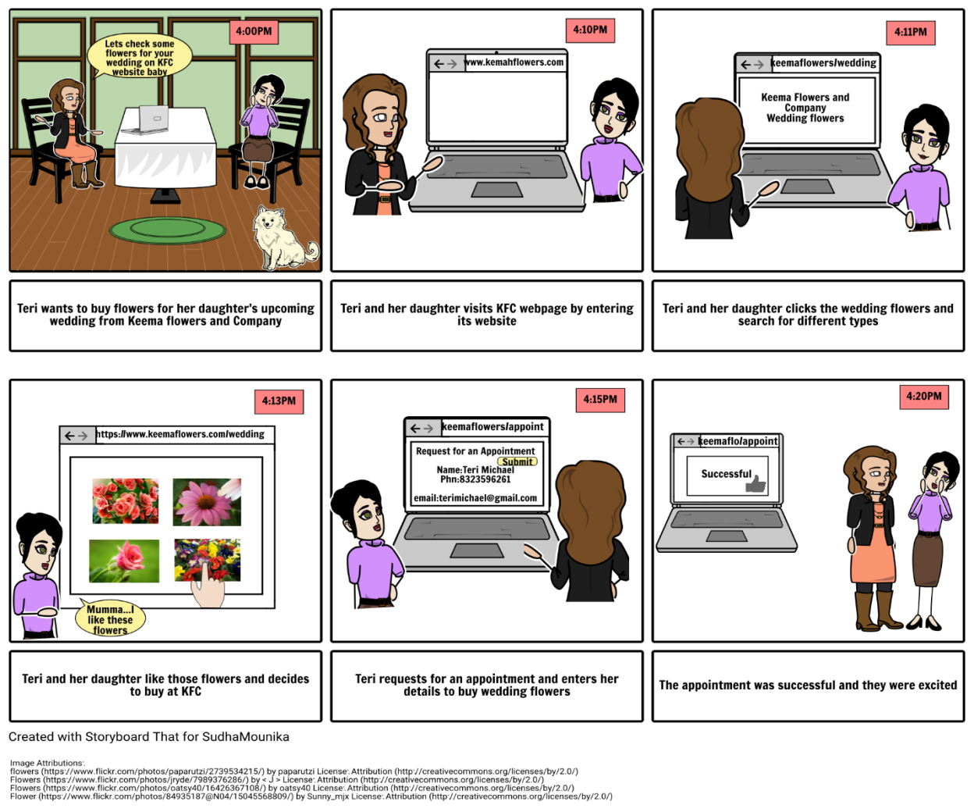

**Scenario two:**

Billy, the manager of KFC, receives a message requesting a meeting for a wedding. Billy checks to see what web pages and images were viewed. He then goes to his Google Calendar to view his available timeslots for appointments. Finally, he calls the new customer to set up the appointment.

1. What does this scenario tell you about TRACKING CUSTOMERS AND COOKIES on the WEBSITE?

A. By tracking customers and cookies on the website, the manager of KFC can check how many customers have visited the page and which image of the flowers were mostly viewed by them. He can check the history so that he can even modify the existing images to the related images which the customers have mostly observed.

2. What does this scenario tell you about adding APPOINTMENT PLANNING to the WEBSITE?

A. Adding appointment planning to the website can schedule the appointments of the customers according to the available time slots. By this type of planning, the manager can easily find the sorted list of customers who have set up their appointments according to their availability so that he can meet them without chaos.

3. What does this scenario tell you about the nature of SPECIAL USER ACCESS to the WEBSITE DATABASE? What information can the manager search and access?

A. A special user can be a manager who can access the website database by scheduling appointments of the customer. He can edit an appointment by rescheduling or cancelling according to the customer’s request. He can even track the customers who have recently visited and the type of flowers which were searched frequently by tracking the cookies.

4. Is there an ORDERING of tasks?

A. Yes, there is an ordering of tasks. As the appointments are scheduled in a timely manner, the tasks are ordered to avoid confusion.

5. What if Billy is not in the office when the message is delivered? How does he get it? (SMS!) How does he do the rest of the stuff remotely? (mobile version of website?)

A. When Billy is not in the office; he gets an alert message to his mobile that a customer is requesting for an appointment. He will sign in to his Kemal Flower Company mobile app and then views his Google Calendar to the available time slot. He sets an appointment with the customer by using KFC mobile app. Then the customer selects the available time slots provided by manager and sets up an appointment through mobile.

6. What does this scenario tell you about the attributes and the entities in the WEBSITE?

A. The attributes and entities in this scenario states us that any customer can send a message to the manager to request a meeting for an occasion. One of the entity, the manager can check which web pages and images were mostly viewed by tracking the cookies. He calls the customer to set up an appointment by viewing his available time slots in his Google Calendar.

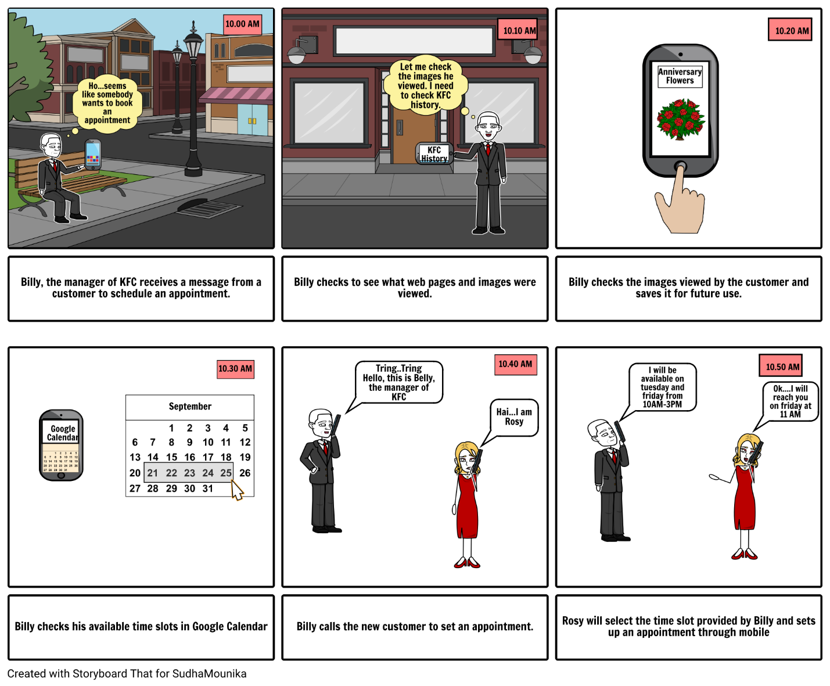

**Scenario three:**

Mario, owner of What’s Happening Events, has a new client in Kemah that wants a Bar Mitzvah planned for his son. Kemah is too far away for Mario’s current florist, so he wants to find a new florist local to the event. He does a search and finds KFC near the top of the search. He requests a call back.

1. What does this scenario tell you about SEARCH TERMS for your WEBSITE?

A. Search bar is located on the top. The customers can search for their nearest location using the search bar. You can also search for anything that you want from the website. For example, if you want florist to be near to the event that you are planning or birthday you can type" birthday" in the search and it will display the content related to it.

2. What is the relationship between CONTRACTOR and SUBCONTRACTOR? (Is it important?)  
A. Sub contractors play a significant role in construction of most projects. Subcontractors take a contract from the contractor. It is important because the managers of KFC might give the contract of developing and enhancing the website to the sub contractors. Sub contractors may be a self employed person or a large organization.

3. What does this scenario tell you about the attributes and the entities in the WEBSITE? There is a search strategy indicated here.

A. Entities involved are the customers who would like to search for their nearest florist. Customers can be managers or party planners.

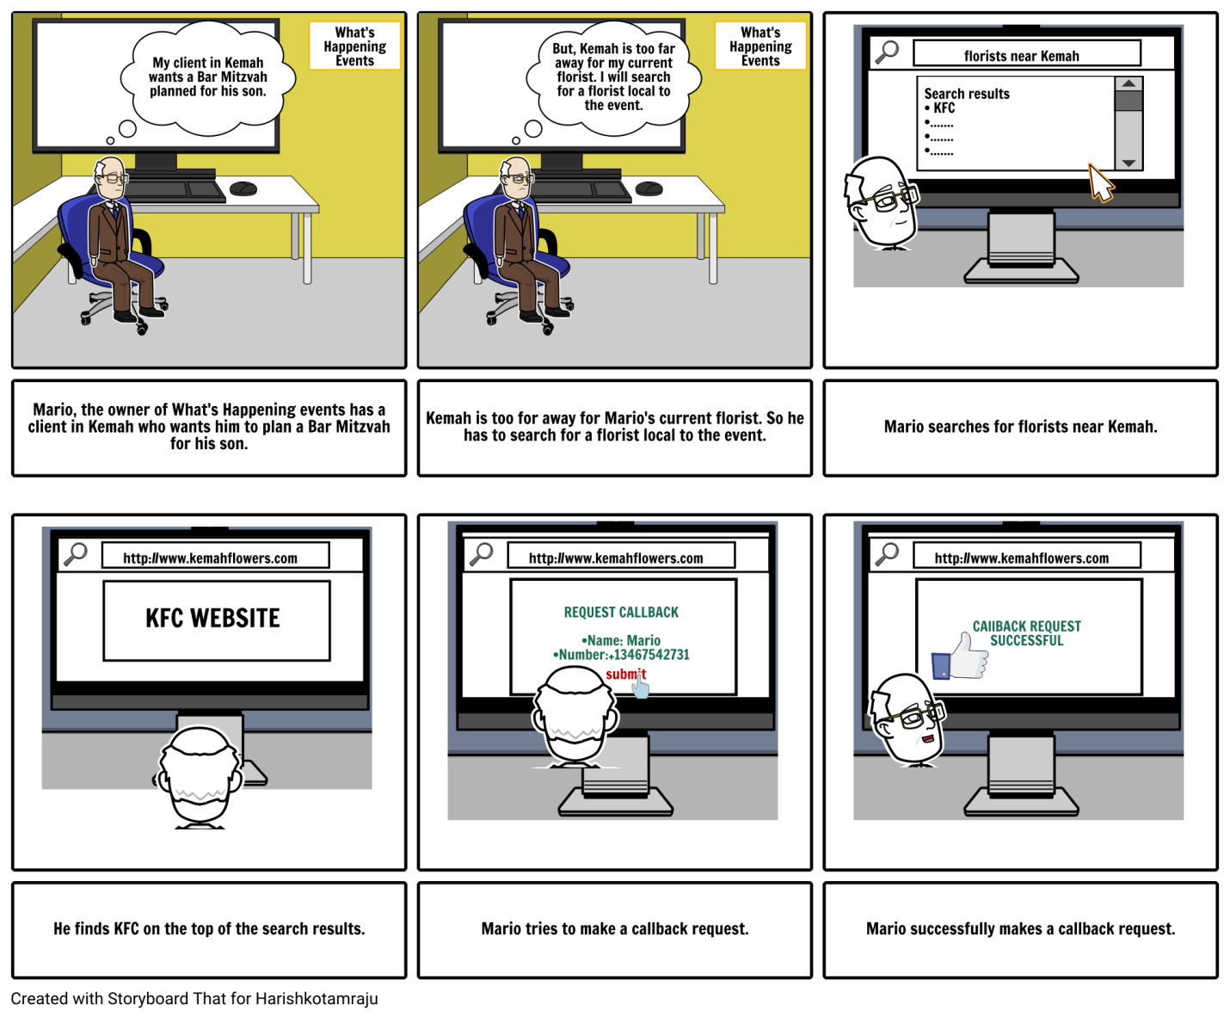

**Scenario four:**

Teagan just had a fantastic time at her Quinceañera, and she especially liked the flowers from Kemah Flowers and Company. She wants to send a “Like” to the Face book® site of KFC and a note of thanks to the company.

1. What does this scenario tell you about RETURNING CUSTOMERS AND COOKIES to your Website?

A. Whenever a customer liked the flowers they may like to visit the website again and buy flowers for some other event. In this case they would like to send a feedback to the KFC as to how they liked their flowers. Every customer has a different way of sending their regards. Some would like to express it through social media and some would visit the website again and buy flowers for some other event.

2. What does this scenario tell you about SOCIAL NETWORKS?

A. Social Networks play an important role in the development of the websites. The customers can give their feedback regarding the website. Based on the customer's feedback the representatives of the KFC website can improve the content of the website.

3. What does this scenario tell you about the attributes and the entities in the WEBSITE?

A. There is a link to the social networking sites face book, twitter and Instagram where you can like their page and keep track of the latest photos of their flowers. Here the entities involved are the customers, the website representatives.

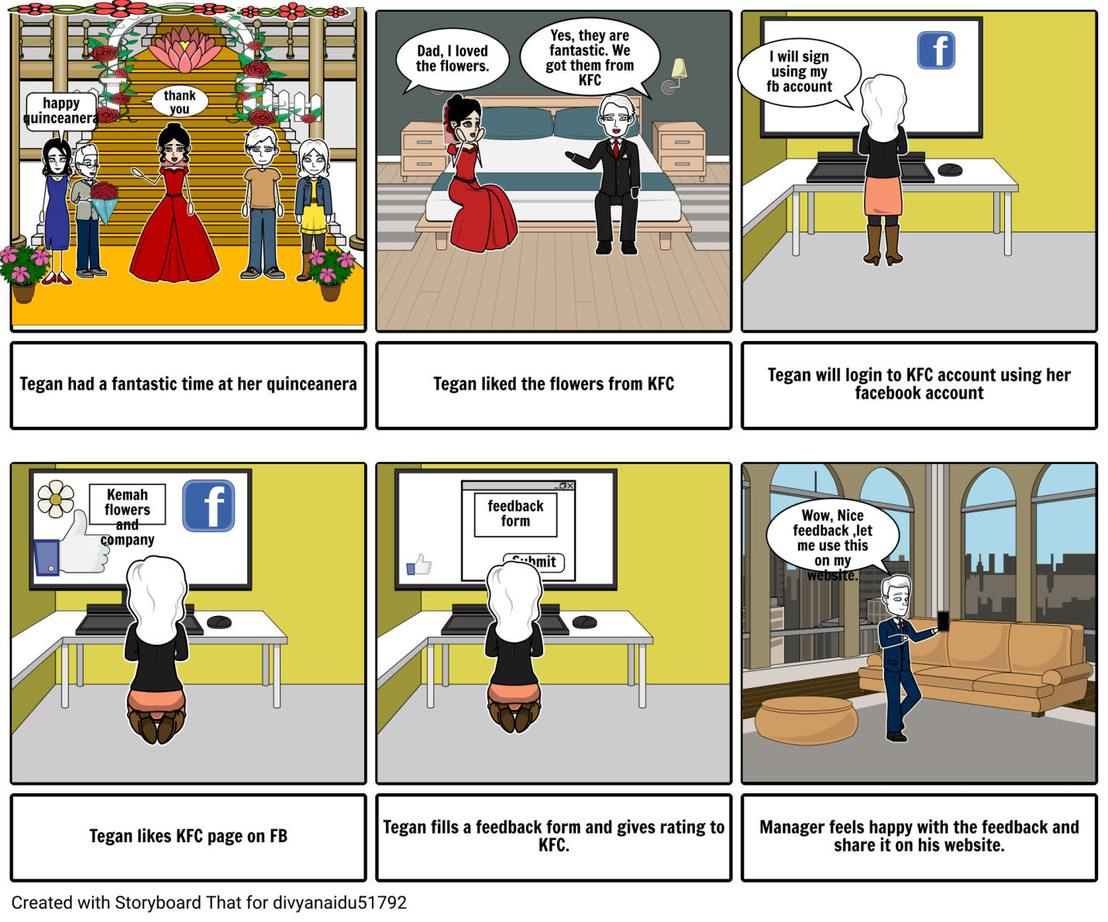

**Scenario five:**

John wants to congratulate his sister Jessy on behalf of her newly born daughter. He wants to surprise Jessy with her favorite tulips. As he lives in another state, he decides to order and send the bouquet through Kemah flowers and Company. John will login to KFC website, selects and order tulips to be delivered to Jessy at her address.

1. What does this scenario tell you about living in different state?

A. As John lives in a different state, he can order her favorite flowers from Kemah flowers and company and he can deliver them to Jessy through this company and surprise her. For this, he need to login to this account, select flowers and place an order with specific date and time to be delivered in order to greet her.

Q2. What does this scenario tell you about providing recipient’s address?

A. As John wants to surprise his sister Jessy, he thought to deliver them directly to her address. He need to provide Jessy’s present address to Kemah Flowers and Company for successful delivery of the flowers.

Q3. What does this scenario tell you about the attributes and entities in the website?

A. The attributes and entities in this scenario states us that, although a sender may live in a different state, he can even send the flowers to the recipient through Kemah Flowers and Company by placing an order and providing the recipient’s present address and contact information.

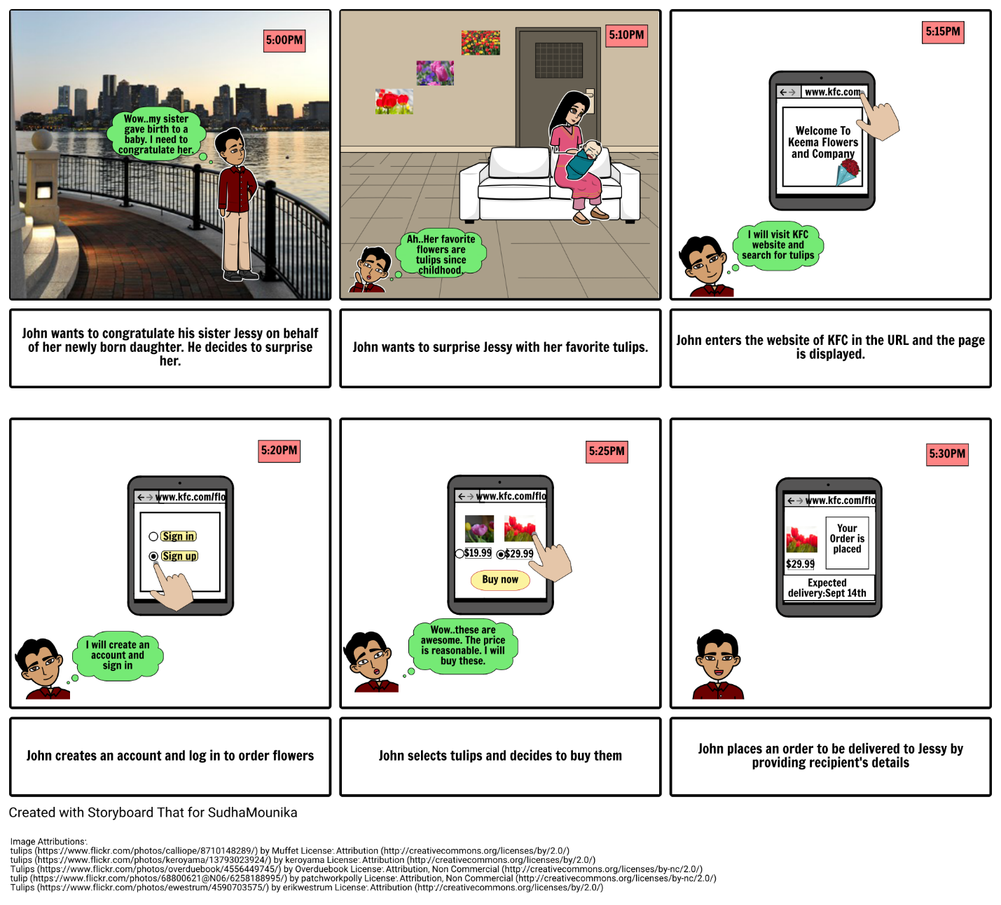

**Scenario six:**

Ram wants to send flowers to his wife Sita on behalf of his first valentine’s day with his wife. He wants to surprise her with her favorite red roses by ordering midnight delivery of flowers. He decides to order and send the red roses through Kemah flowers and Company midnight delivery process. He will login to KFC website, selects and order red roses to be delivered to their address on 14th February at 12: AM.

1. What does this scenario tell you about midnight delivery?

A. As Ram was busy in his daily routine; it became difficult for him to plan for a surprise in short time. He wants to make his first valentine’s day, the memorable one by sending red roses through KFC midnight flower delivery process. Using midnight flower delivery process, the KFC can deliver the ordered flowers on a specific day at 12:00AM.

2. What does this scenario tell you about providing specific details of the day?

A. By providing specific details like the exact date and time, the process can be made on that particular day to avoid chaos. The delivery of flowers according to the exact date plan can be successful by providing the date and time specifically when you are placing an order.

3. What does this scenario tell you about the attributes and entities in the website?

A. The attributes and entities in this website states that, in our busy schedule, we can plan surprises to our loved ones in a short amount of time by ordering at Kemah Flowers and Company midnight flower delivery process and providing specific delivery details.

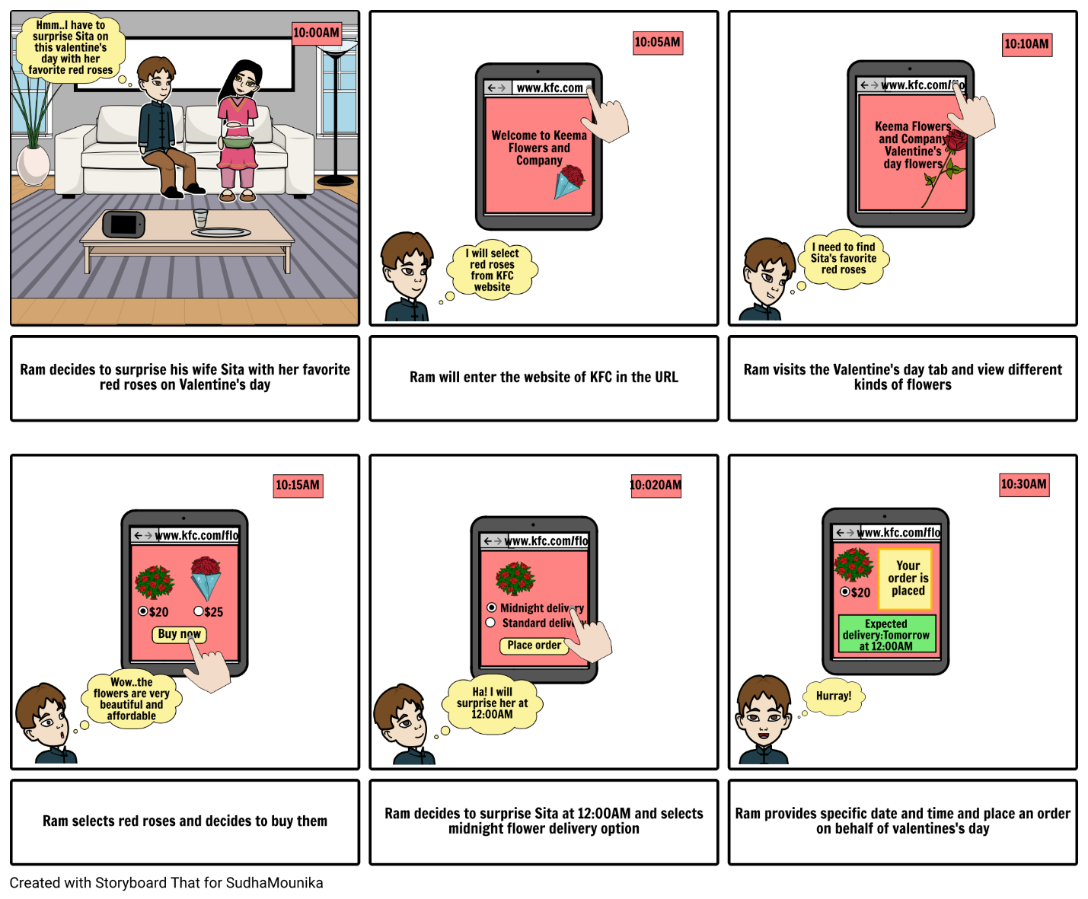

**Scenario seven:**

Tim and his friends are graduating this week and they all decide to throw a party to their friends and relatives. They didn’t have enough time to buy flowers and decorate the venue. So they visited KFC website and look for different kinds of flowers. They decide to buy and hence scheduled an appointment with the KFC.

1.What does this scenario tell you about "schedule an appointment “?

A.  Schedule an appointment plays a crucial role in KFC website. This helps customer in scheduling an appointment with the manager in a suitable time for both of them.

2.How does customer information help you in sending emails to the customer?

A. Customer information includes name, contact information and also his birthday. Here in the website we include a calendar which sends a timely notification. By using customer information, we can send an email him on his every birthday including birthday wishes and also offering some new deals to attract the customer, so that he might celebrate his next event with KFC.

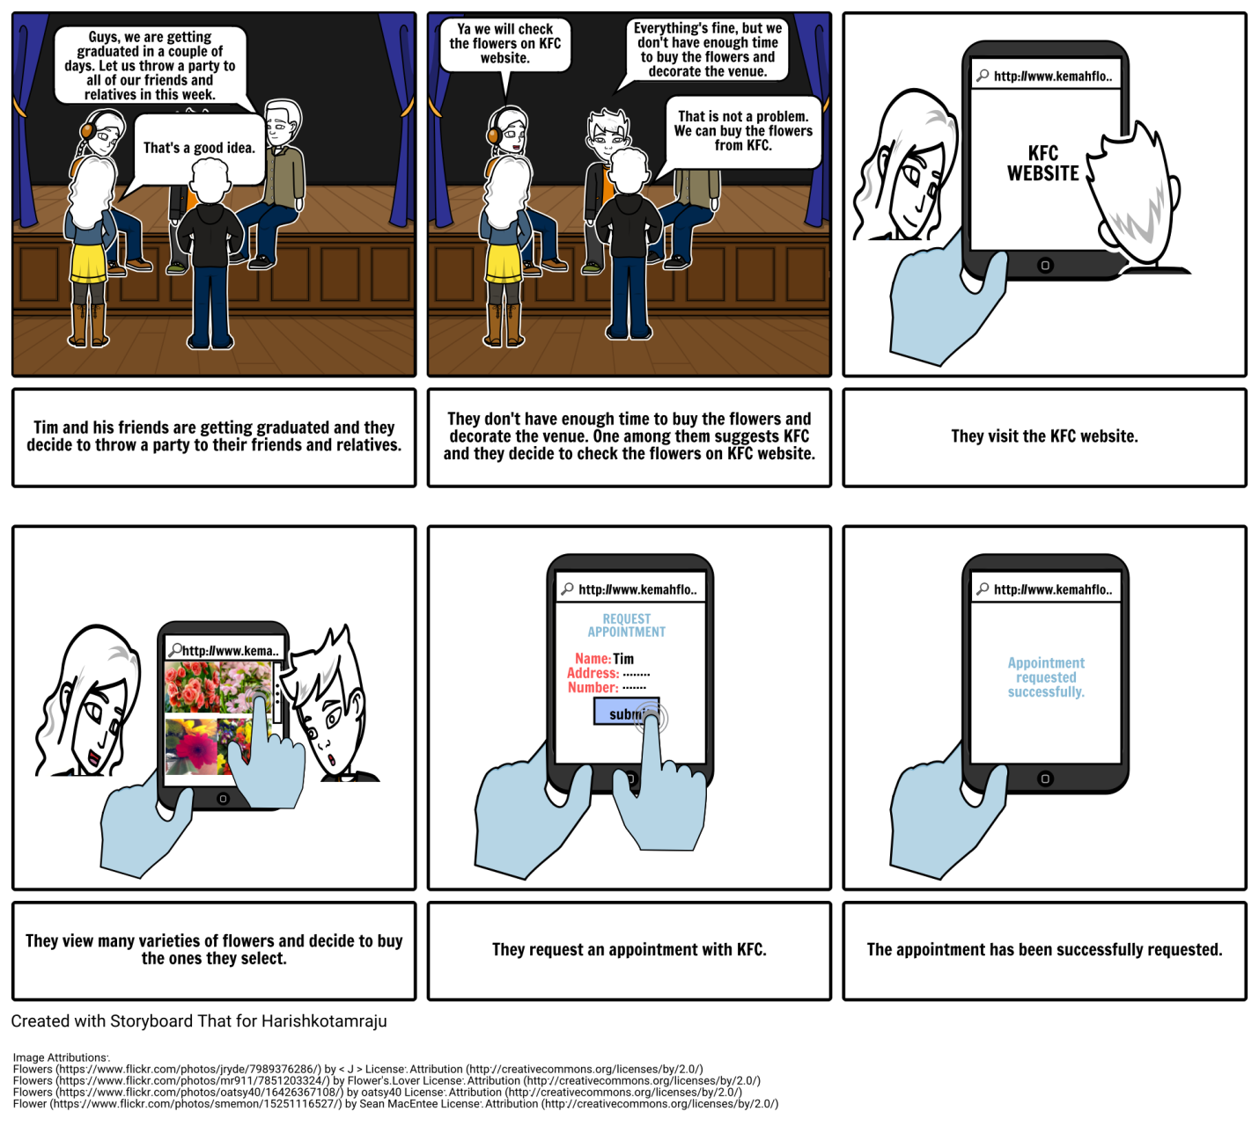

**Scenario Eight:**

As a promotion to website “refer and earn” feature is enabled for KFC website. Rory get an option on her profile as “Refer and Earn”. She clicks on it and sends the invitation to her friend Mary. Mary receives an email invitation. She signs up into KFC using her friend’s referral code and earns points after her first purchase

1.What does this scenario tell you about “Refer and Earn” to your website?

“Refer and Earn” describes the process of referring a friend and earning reward points. This is a very good promotional plan to the website.

2.What does this scenario tell you about nature of “customer information” in your website?

Customer information helps in finding out the name and reason for visiting the website, so that related images are displayed. Moreover, customer information helps in identifying the needs of customer and also to send messages or timely notifications.

3. What is the nature of “Beneficiary” and “referrer”?

A. Beneficiary is the new customer and he gets benefited with reward points. Referrer is the existing customer who refers his friend, by which both of them gets benefit.

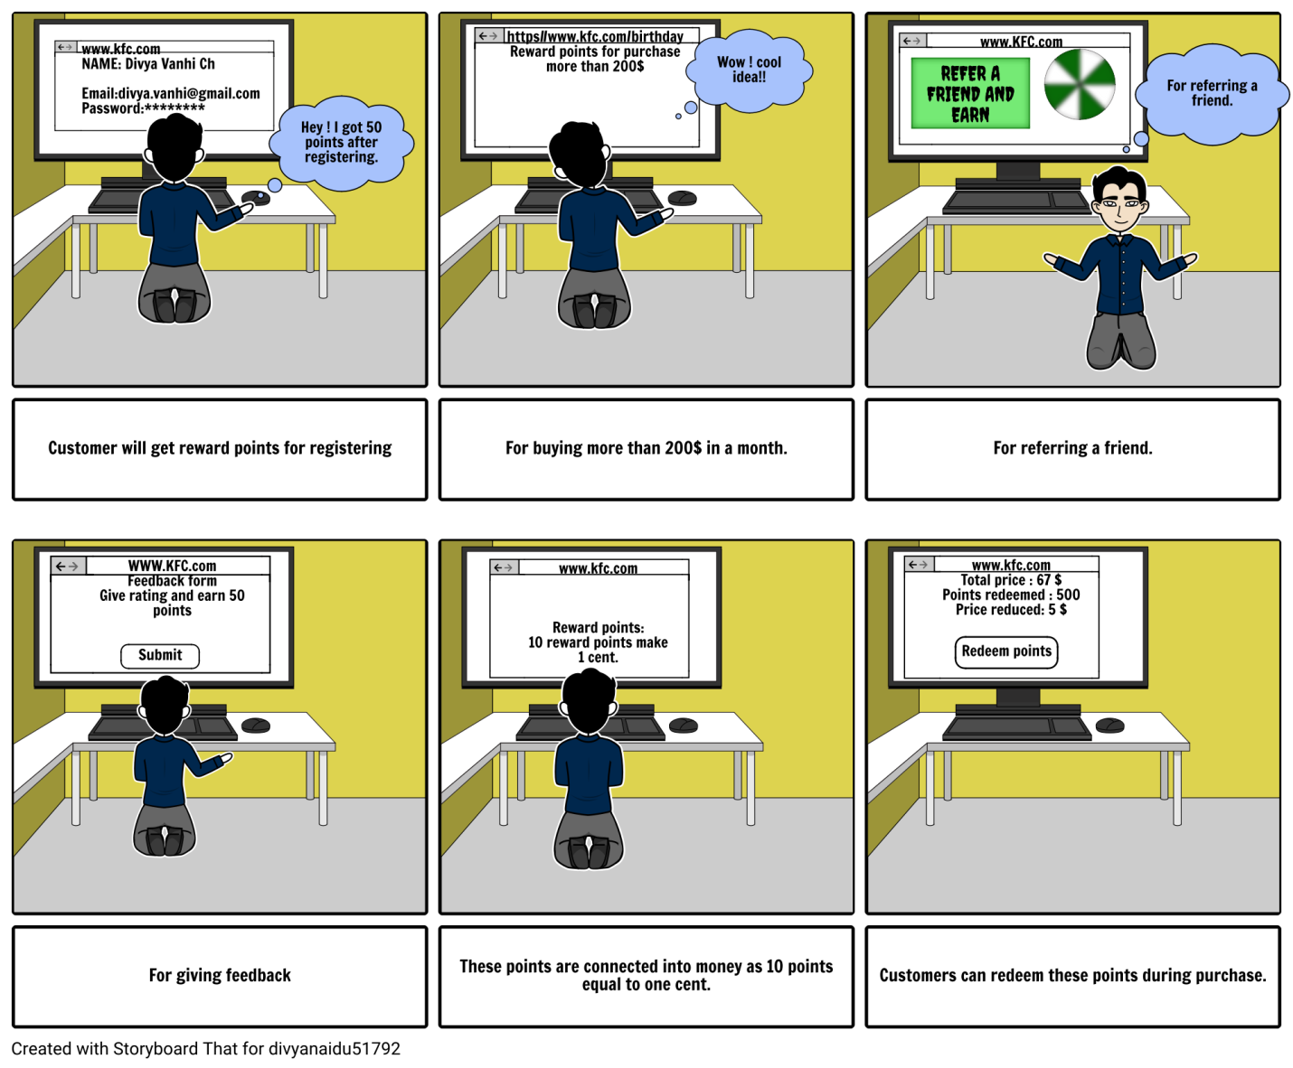

**Creative Extra:**

Carolina buys KFC flowers for her birthday and she receives 30% discount voucher to her mail. During her next birthday, she remembers the coupon from KFC and uses the voucher during her purchase and gets excited when the she finds out the reduced price.

1.What does this scenario tell you about “returning customer”?

A. Returning customers are the existing customers who already made one or more purchases. In this scenario returning customers are given privilege with discount vouchers.

2. What does this scenario tell you about “customer information”?

A. Customer information includes name, date of birth and previous events arranged through which timely notifications can be sent. This also includes email id, to which discount vouchers and notifications are sent.

